\

JenkinsFromScratch



**By:MADHUKAR REDDY VENNA**

Jenkins

Jenkins is a powerful application that allows continuous integration and continuous delivery ofprojects, regardless of the platform you are working on. It is a free source that can handle anykind of build or continuous integration. You can integrate Jenkins with a number of testing anddeployment technologies. In this tutorial, we would explain how you can use Jenkins to buildandtestyour software projectscontinuously.

## WhyJenkins?

Jenkins is a software that allows **continuous integration**. Jenkins will be installed on aserver where the central build will take place. The following flowchart demonstrates averysimple workflowofhowJenkinsworks.

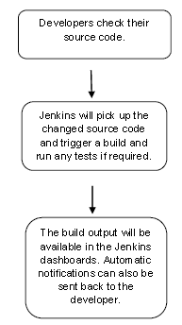

Along with Jenkins, sometimes, one might also see the association of **Hudson**. Hudsonisaverypopularopen-sourceJava-basedcontinuousintegrationtooldevelopedbySunMicrosystems which was later acquired by Oracle. After the acquisition of Sun by Oracle,a fork was created from the Hudson source code, which brought about the introductionofJenkins.

*2*

## WhatisContinuousIntegration?

*3*

Continuous Integration is a development practice that requires developers to integratecodeintoasharedrepositoryatregularintervals.Thisconceptwasmeanttoremovetheproblem of finding later occurrence of issues in the build lifecycle. Continuousintegrationrequiresthedeveloperstohavefrequentbuilds.Thecommonpracticeisthatwheneveracodecommit occurs,abuild shouldbetriggered.

**SystemRequirements**

|  |  |
| --- | --- |
| **JDK** | **JDK1.5orabove** |
| **Memory** | 2GBRAM(recommended) |
| **DiskSpace** | Nominimumrequirement.NotethatsinceallbuildswillbestoredontheJenkinsmachines, ithas tobeensuredthat  sufficientdiskspaceisavailableforbuildstorage. |
| **OperatingSystemVersion** | Jenkins can be installed on Windows, Ubuntu/Debian, RedHat/Fedora/CentOS, Mac OS X, openSUSE, FReeBSD,OpenBSD,GentooorDocker or AWS |
| **JavaContainer** | The WAR file can be run in any container that supportsServlet2.4/JSP2.0orlater.(AnexampleisTomcat5). |

# Jenkins-Installation

## DownloadJenkins

The official website for Jenkins is Jenkins. If you click the given link, you can get thehomepageoftheJenkinsofficialwebsite as shownbelow.

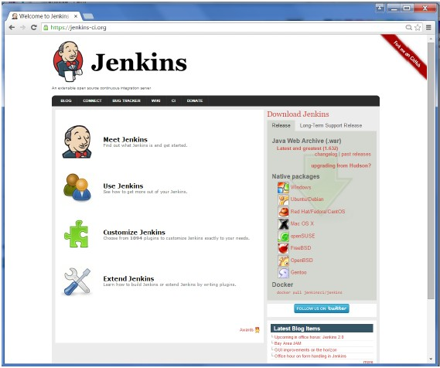

*4*

By default, the latest release and the Long-Term support release will be available fordownload. The past releases are also available for download. Click the Long-TermSupportReleasetabinthedownload section.

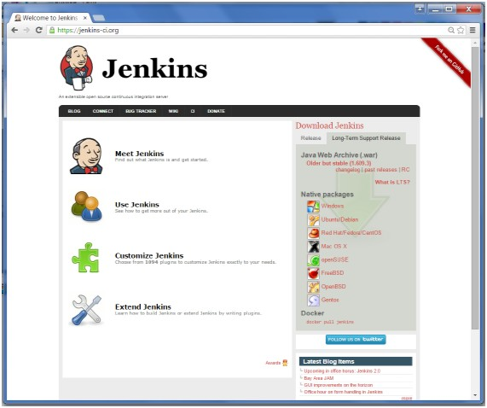

Clickthelink“Olderbutstableversion”todownloadtheJenkinswarfile.

## StartingJenkins

Openthecommandprompt.Fromthecommandprompt,browsetothedirectorywherethejenkins.warfileispresent.Runthefollowingcommand

D:\>Java–jarJenkins.war

After the command is run, various tasks will run, one of which is the extraction of thewarfilewhichisdone byanembedded webservercalledwinstone.

D:\>Java–jarJenkins.war

*5*

Running from: D:\jenkins.warWebroot:$user.home/.jenkins

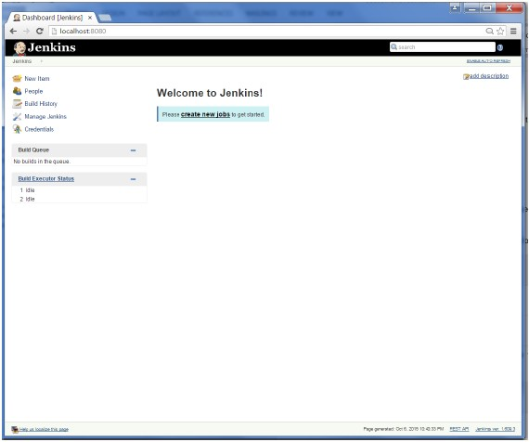

Sep29,20154:10:46PMwinstone.LoggerlogInternalINFO:Beginningextraction fromwar file

Oncetheprocessingiscompletewithoutmajorerrors,thefollowinglinewillcomeintheoutput ofthecommand prompt.

INFO:Jenkinsisfullyupandrunning

## AccessingJenkins

OnceJenkinsisupandrunning,onecanaccessJenkinsfromthelink−

### http://localhost:8080

ThislinkwillbringuptheJenkinsdashboard.

*6*

# Jenkins–TomcatSetup

*7*

ThefollowingprerequisitesmustbemetforJenkinsTomcatsetup.

## Step1:VerifyingJavaInstallation

ToverifyJavainstallation,opentheconsoleandexecutethefollowingjavacommand.

|  |  |  |
| --- | --- | --- |
| OS | Task | Command |
| **Windows** | Opencommand console | \>java–version |
| **Linux** | Opencommandterminal | $java–version |

IfJavahasbeeninstalledproperlyonyoursystem,thenyoushouldgetoneofthefollowingoutputs, dependingon theplatformyouareworkingon.

|  |  |
| --- | --- |
| OS | Output |
| **Windows** | Javaversion"1.7.0_60"  Java(TM)SERunTime Environment(build1.7.0_60-b19)  JavaHotspot(TM)64-bitServerVM(build24.60-b09,mixedmode) |
| **Linux** | javaversion"1.7.0_25"  Open JDK Runtime Environment (rhel-2.3.10.4.el6_4-x86_64)OpenJDK64-BitServerVM(build23.7-b01,mixedmode) |

WeassumethereadersofthistutorialhaveJava1.7.0_60installedontheirsystembeforeproceeding for thistutorial.

Incaseyoudonot haveJavaJDK,youcandownloaditfromthelinkOracle

## Step2:VerifyingJavaInstallation

Set the JAVA_HOME environment variable to point to the base directory location whereJavaisinstalled on yourmachine.For example,

|  |  |
| --- | --- |
| OS | Output |
| **Windows** | SetEnvironmentalvariableJAVA_HOMEtoC:\ProgramFiles\java\jdk1.7.0_60 |
| **Linux** | exportJAVA_HOME=/usr/local/java-current |

Appendthefullpath oftheJava compilerlocationto theSystemPath.

zipfile.

*8*

|  |  |
| --- | --- |
| OS | Output |
| **Windows** | Append the String; C:\Program Files\Java\jdk1.7.0_60\bin to the end of the systemvariablePATH. |
| **Linux** | exportPATH=$PATH:$JAVA_HOME/bin/ |

Verifythecommandjava-versionfromcommandpromptasexplainedabove.

## Step3:DownloadTomcat

The official website for tomcat is Tomcat. If you click the given link, you can get thehomepageofthetomcat official websiteasshownbelow.

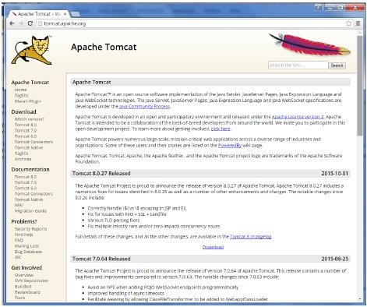

Browse to the link https://tomcat.apache.org/download-70.cgito get the download fortomcat.

Go to the ‘Binary Distributions’ section. Download the 32-bit WindowsThenunzip thecontentsofthedownloadedzipfile.

## Step4:Jenkinsand TomcatSetup

*9*

CopytheJenkis.warfilewhichwasdownloadedfromtheprevioussectionandcopyittothewebappsfolderinthetomcat folder.

Now open the command prompt. From the command prompt, browse to the directorywhere the tomcat7 folder is location. Browse to the bin directory in this folder and runthestart.bat file

E:\Apps\tomcat7\bin>startup.bat

Once the processing is complete without major errors, the following line will come intheoutput ofthecommand prompt.

INFO:Serverstartupin1302ms

Openthebrowserandgotothelink−**http://localhost:8080/jenkins**.Jenkinswillbeupand runningontomcat.

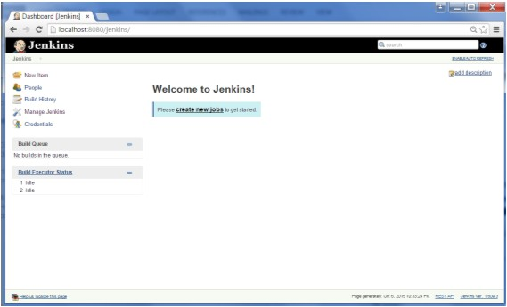

# Jenkins-GitSetup

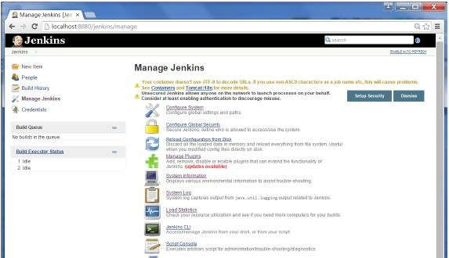

*10*

For this exercise, you have to ensure that Internet connectivity is present from themachineonwhichJenkinsisinstalled.InyourJenkinsDashboard(Homescreen),clicktheManageJenkinsoptiononthelefthand side.

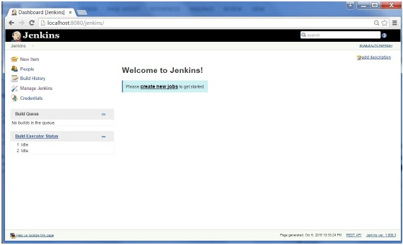

Inthenextscreen,clickthe‘ManagePlugins’option.

In the next screen, click the Available tab. This tab will give a list of plugins which areavailablefordownloading.Inthe‘Filter’ tab type‘Gitplugin’

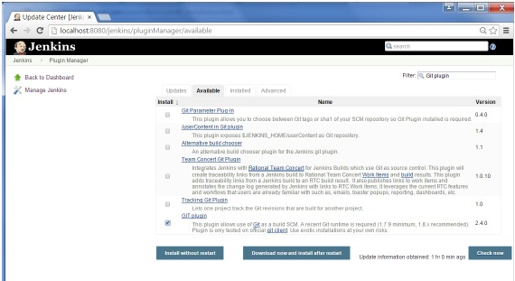

Theinstallationwillthenbeginandthescreenwillberefreshedto showthestatusofthedownload.

*11*

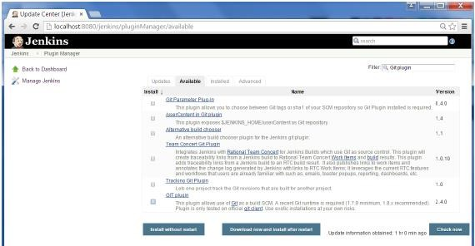

Thelistwillthenbe filtered.ChecktheGitPluginoptionandclickonthebutton‘Installwithoutrestart’

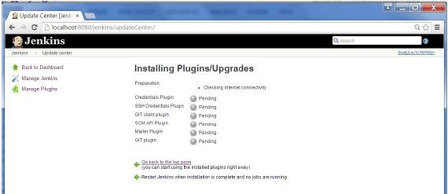

Onceallinstallationsarecomplete,restartJenkinsbyissuethefollowingcommandinthebrowser.**http://localhost:8080/jenkins/restart**

After Jenkins is restarted, Git will be available as an option whilst configuring jobs. Toverify,clickonNewIteminthemenuoptionsforJenkins.Thenenteranameforajob,inthe following case, the name entered is ‘Demo’. Select ‘Freestyle project’ as the itemtype.Clickthe Okbutton.

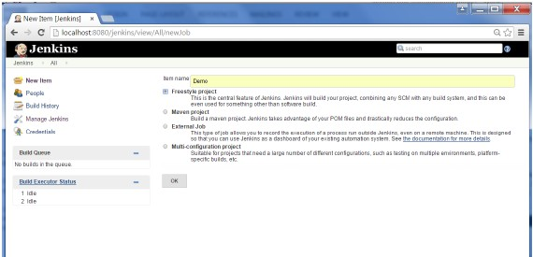

Inthenextscreen,ifyoubrowsetotheSourcecodeManagementsection,youwillnowsee‘Git’asan option.

*12*

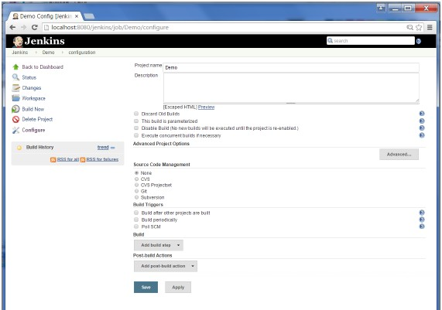

*13*

# Jenkins–MavenSetup

## Step1:DownloadingandSettingUpMaven

The official website for maven is Apache Maven. If you click the given link, you can getthehomepageofthe mavenofficialwebsite asshownbelow.

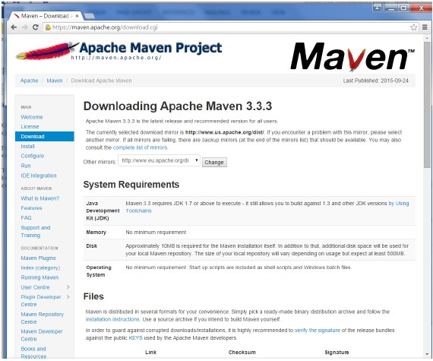

*14*

While browsing to the site, go to the Files section and download the link to theBinary.zipfile.

Once the file is downloaded, extract the files to the relevant application folder. For thispurpose,themavenfileswillbeplaced inE:\Apps\apache-maven-3.3.3.

## Step2:SettingupJenkinsandMaven

In the Jenkins dashboard (Home screen), click Manage Jenkins from the left-hand sidemenu.

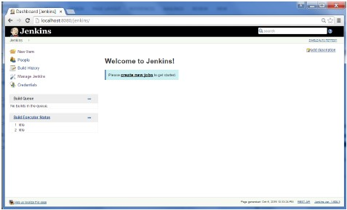

*15*

Then,clickon‘ConfigureSystem’fromtherighthandside.

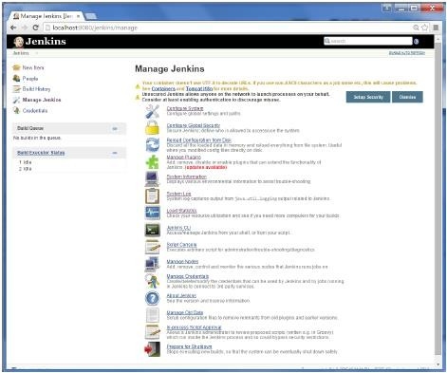

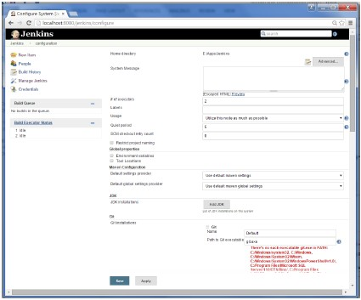

*16*

IntheConfiguresystemscreen,scrolldowntillyouseethe Mavensectionandthenclickonthe‘Add Maven’button.

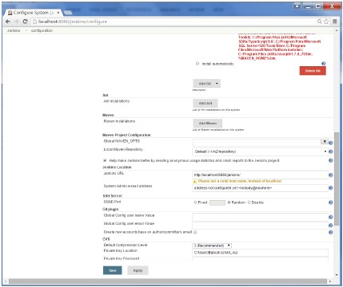

Uncheckthe‘Installautomatically’option.

Addanynameforthe settingandthelocationoftheMAVEN_HOME.Then,clickon the‘Save’buttonat theend ofthescreen.

*17*

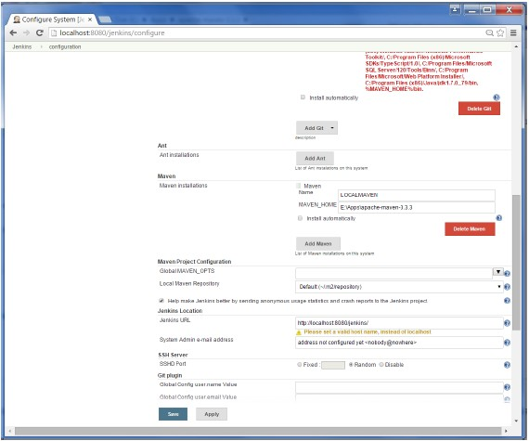

Youcannowcreateajob withthe‘Mavenproject’option.IntheJenkinsdashboard,clicktheNew Itemoption.

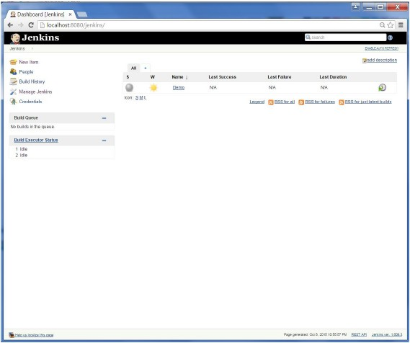

*18*

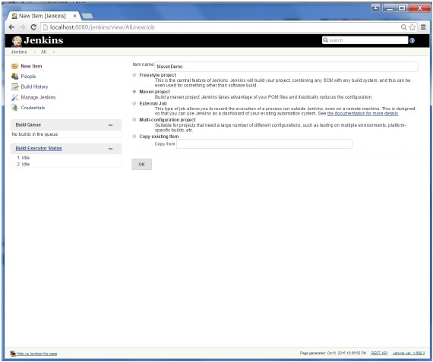

*19*

# Jenkins-Configuration

You probably would have seen a couple of times in the previous exercises wherein wehadtoconfigureoptionswithinJenkins.ThefollowingshowsthevariousconfigurationoptionsinJenkins.

So one can get the various configuration options for Jenkins by clicking the ‘ManageJenkins’option fromthelefthand menuside.

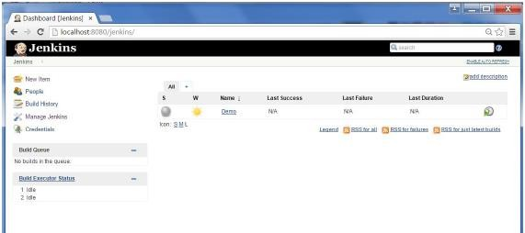

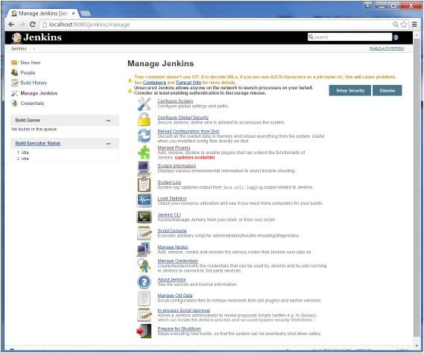

Youwillthenbepresentedwiththefollowingscreen −

ClickonConfiguresystem.DiscussedbelowaresomeoftheJenkinsconfigurationsettingswhichcanbecarried out.

*20*

## JenkinsHomeDirectory

*21*

Jenkins needs some disk space to perform builds and keep archives. One can check thislocationfromtheconfigurationscreenofJenkins.Bydefault,thisissetto~/.jenkins,andthis location will initially be stored within your user profile location. In a properenvironment, you need to change this location to an adequate location to store allrelevantbuildsand archives. Oncecando thisinthefollowingways

*Set"JENKINS_HOME"environmentvariabletothenewhomedirectorybeforelaunchingtheservletcontainer.

*Set"JENKINS_HOME"systempropertytotheservletcontainer.

*SetJNDIenvironmententry"JENKINS_HOME"tothenewdirectory.

Thefollowingexamplewillusethefirstoptionofsettingthe"JENKINS_HOME"environmentvariable.

Firstcreatea newfolderE:\Apps\Jenkins.Copyallthecontentsfromtheexisting

~/.jenkinstothisnewdirectory.

SettheJENKINS_HOMEenvironmentvariabletopointtothebasedirectorylocationwhereJava isinstalledonyour machine.Forexample,

|  |  |
| --- | --- |
| OS | Output |
| **Windows** | Set Environmental variable JENKINS_HOME to you’re the location you desire. Asanexampleyou can setittoE:\Apps\Jenkins |
| **Linux** | exportJENKINS_HOME =/usr/local/Jenkinsorthelocationyoudesire. |

In the Jenkins dashboard, click Manage Jenkins from the left hand side menu. Then clickon‘ConfigureSystem’fromtheright handside.

IntheHomedirectory,youwillnowsee thenewdirectory whichhasbeenconfigured.

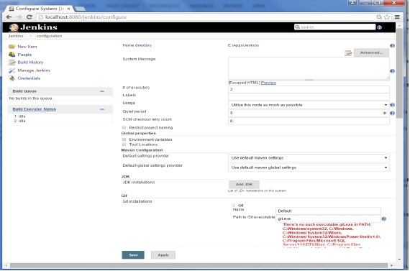

## #ofexecutors

This refers to the total number of concurrent job executions that can take place on theJenkins machine. This can be changed based on requirements. Sometimes therecommendation is to keep this number the same as the number of CPU on themachinesforbetterperformance.

## EnvironmentVariables

Thisisusedtoaddcustomenvironmentvariableswhich willapplyto allthejobs.Thesearekey-valuepairsandcanbeaccessedandusedin Buildswhereverrequired.

## JenkinsURL

By default, the Jenkins URL points to localhost. If you have a domain name setup foryour machine, set this to the domain name else overwrite localhost with IP of machine.Thiswillhelpinsettingupslavesandwhilesendingoutlinksusingtheemailasyoucandirectly access the Jenkins URL using the environment variable JENKINS_URL which canbeaccessedas${JENKINS_URL}.

*22*

## EmailNotification

*23*

In the email Notification area, you can configure the SMTP settings for sending outemails. ThisisrequiredforJenkinstoconnecttotheSMTPmailserverandsendoutemailsto therecipientlist.

# Jenkins-Management

TomanageJenkins,clickonthe‘ManageJenkins’optionfromthelefthandmenuside.

SoonecangetthevariousconfigurationoptionsforJenkinsbyclickingthe‘ManageJenkins’option fromthelefthand menuside.

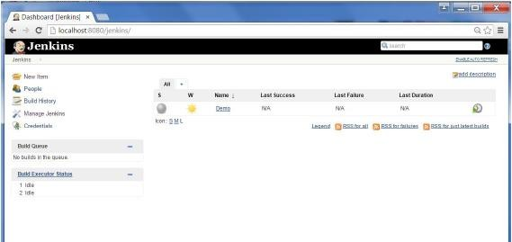

Youwillthenbepresentedwith thefollowingscreen −

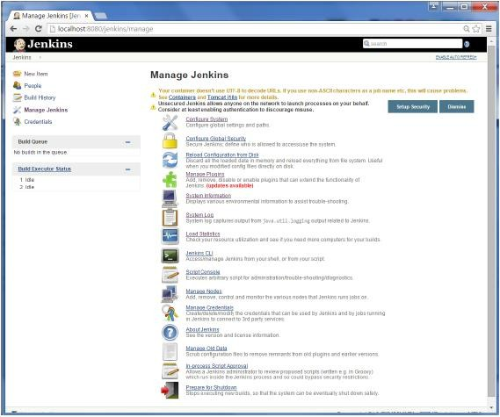

Someofthemanagementoptionsareasfollows −

## ConfigureSystem

This is where one can manage paths to the various tools to use in builds, such as theJDKs, the versions of Ant and Maven, as well as security options, email servers, and othersystem-wide configuration details. When plugins are installed. Jenkins will add therequiredconfigurationfieldsdynamicallyafterthepluginsareinstalled.

## ReloadConfigurationfromDisk

Jenkins stores all its system and build job configuration details as XML files which isstored in the Jenkins home directory. Here also all of the build history is stored. If youare migrating build jobs from one Jenkins instance to another, or archiving old buildjobs,youwillneedtoaddorremovethecorrespondingbuildjobdirectoriestoJenkins’sbuildsdirectory.Youdon’t need totakeJenkinsofflineto dothis—youcansimplyuse

*24*

the“ReloadConfigurationfromDisk”optiontoreloadtheJenkinssystemandbuildjobconfigurationsdirectly.

## ManagePlugin

Here one can install a wide variety of third-party plugins right from different Sourcecode management tools such as Git, Mercurial or ClearCase, to code quality and codecoverage metrics reporting. Plugins can be installed, updated and removed through theManagePluginsscreen.

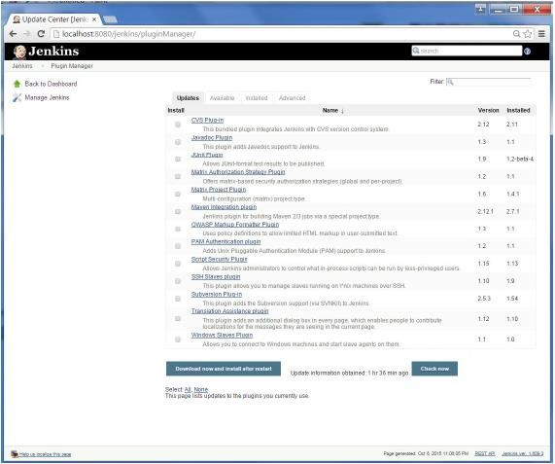

## SystemInformation

This screen displays a list of all the current Java system properties and systemenvironmentvariables.HereonecancheckexactlywhatversionofJavaJenkinsisrunningin, what user itisrunningunder,and soforth.

*25*

Thefollowingscreenshotshowssomeofthename-valueinformationavailableinthissection.

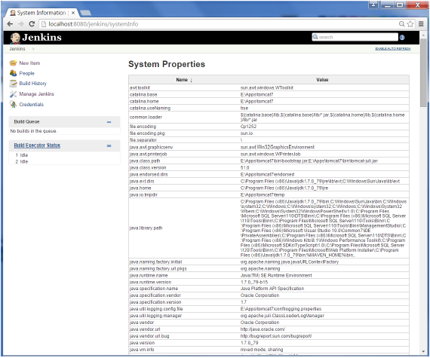

### SystemLog

TheSystemLog screenisa convenientwaytoviewtheJenkinslogfilesinrealtime.Again,themainuseof thisscreenisfortroubleshooting.

### LoadStatistics

This pages displays graphical data on how busy the Jenkins instance is in terms of thenumberofconcurrentbuildsandthelength ofthebuildqueuewhichgivesan ideaofhow long your builds need to wait before being executed. These statistics can give agood idea of whether extra capacity or extra build nodes is required from aninfrastructureperspective.

*26*

### ScriptConsole

*27*

This screen lets you run Groovy scripts on the server. It is useful for advancedtroubleshootingsinceitrequiresastrongknowledgeoftheinternalJenkinsarchitecture.

### Managenodes

Jenkins is capable of handling parallel and distributed builds. In this screen, you canconfigure how many builds you want. Jenkins runs simultaneously, and, if you are usingdistributed builds, set up build nodes. A build node is another machine that Jenkins canuseto execute itsbuilds.

### PrepareforShutdown

Ifthereisaneedto shutdownJenkins,ortheserverJenkinsisrunningon,itisbest notto do so when a build is being executed. To shut down Jenkins cleanly, you can use thePrepareforShutdownlink,whichpreventsanynewbuildsfrombeing started.

Eventually, when all of the current builds have finished, one will be able to shut downJenkinscleanly.

# Jenkins-SetupBuildJobs

Forthisexercise,wewillcreate ajobinJenkinswhichpicksupasimpleHelloWorldapplication,buildsand runsthejavaprogram.

**Step1**−GototheJenkinsdashboard andClickonNewItem

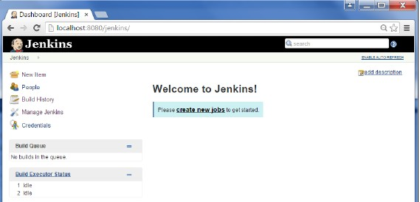

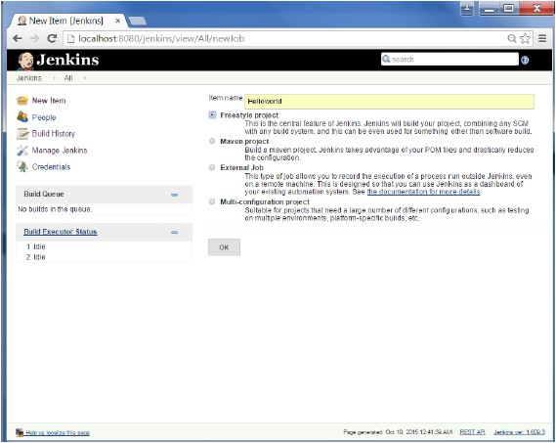

**Step2**−Inthenext screen, entertheItemname, inthiscase wehavenamed itHelloworld.Choosethe‘Freestyleprojectoption’

*28*

**Step 3** − The following screen will come up in which you can specify the details of thejob.

*29*

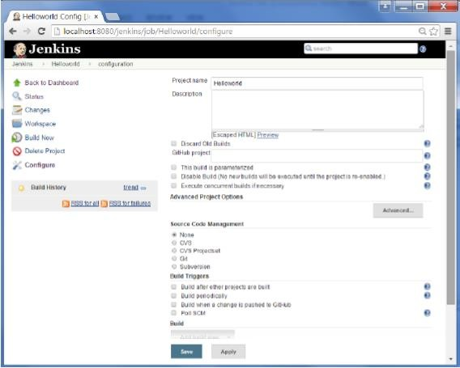

**Step 4** − We need to specify the location of files which need to be built. In this example,we will assume that a local git repository(E:\Program) has been setup which contains a‘HelloWorld.java’file.HencescrolldownandclickontheGitoptionandentertheURLofthelocalgitrepository.

**Note** − If you repository if hosted on Github, you can also enter the url of thatrepository here. In addition to this, you would need to click on the Add button for thecredentialstoaddausernameand passwordtothegithubrepositorysothatthecodecanbepickedup from theremoterepository.

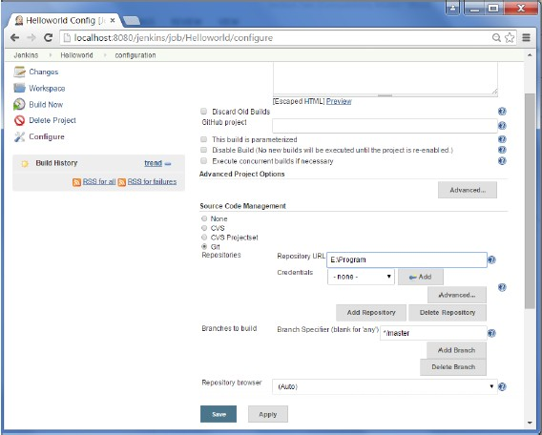

*30*

**Step5**−NowgototheBuildsectionandclickonAddbuildstep→ExecuteWindowsbatchcommand

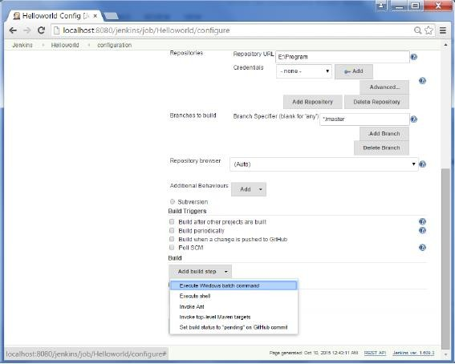

*31*

**Step 6** − In the command window, enter the following commands and then click on theSavebutton.

JavacHelloWorld.javaJavaHelloWorld

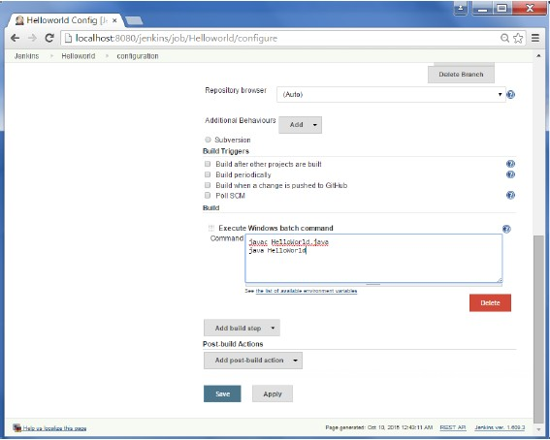

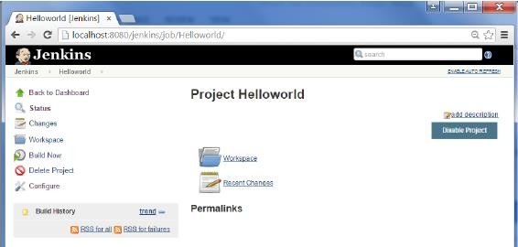

*32*

**Step7**−Once saved, youcanclickontheBuildNowoption toseeifyouhavesuccessfullydefinedthejob.

**Step8**−Oncethebuildisscheduled,itwillrun.ThefollowingBuildhistorysectionshowsthat abuild is inprogress.

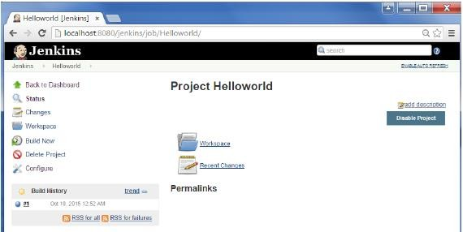

**Step10**−ClickontheConsoleOutputlinktoseethedetailsofthebuild

*33*

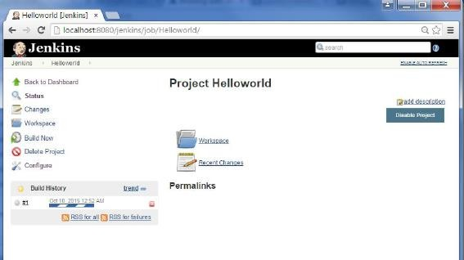

**Step 9** − Once the build is completed, a status of the build will show if the build wassuccessfulornot.Inourcase,thefollowingbuildhasbeenexecutedsuccessfully.Clickonthe#1in theBuildhistorytobringup thedetailsof thebuild.

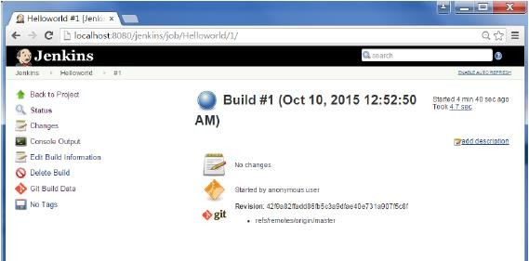

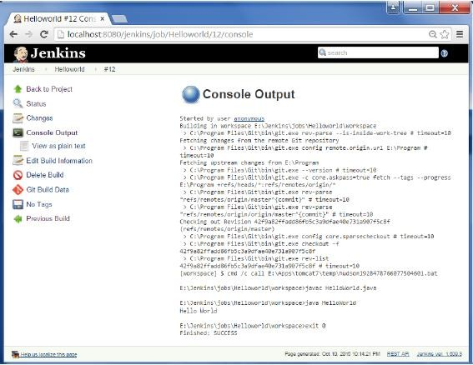

Apartfromthestepsshownabovetherearejustsomanywaystocreateabuildjob, theoptions available are many, which what makes Jenkins such a fantastic continuousdeploymenttool.

*34*

# Jenkins-UnitTesting

Jenkins provides an out of box functionality for Junit, and provides a host of plugins forunit testing for other technologies, an example being MSTest for .Net Unit tests. If yougo to the link https://wiki.jenkins-ci.org/display/JENKINS/xUnit+Pluginit will give the listofUnitTesting plugins available.

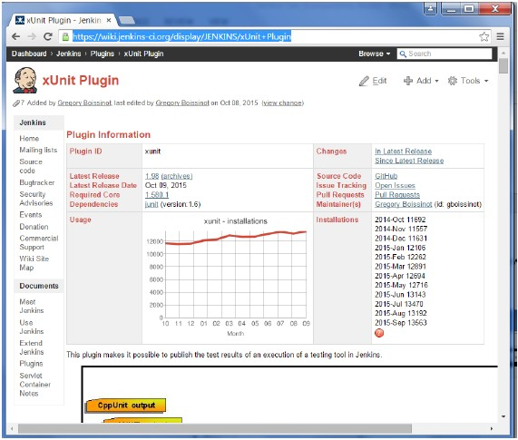

## ExampleofaJunitTestinJenkins

Thefollowingexamplewillconsider

* AsimpleHelloWorldTestclassbasedonJunit.
* AntasthebuildtoolwithinJenkinstobuildtheclassaccordingly.

**Step 1** − Go to the Jenkins dashboard and Click on the existing HelloWorld project andchoosetheConfigureoption

*35*

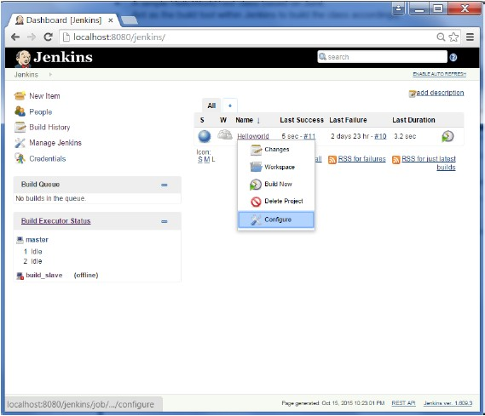

*36*

**Step2**−BrowsetothesectiontoAddaBuildstepandchoosetheoptiontoInvokeAnt.

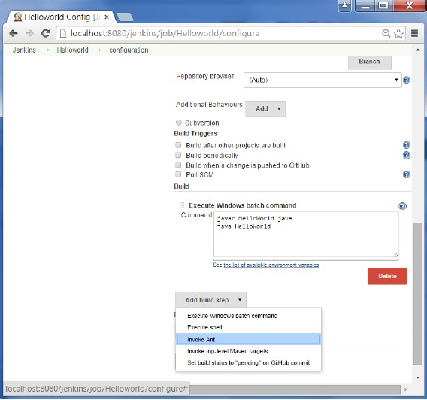

*37*

**Step3**−ClickontheAdvancedbutton.

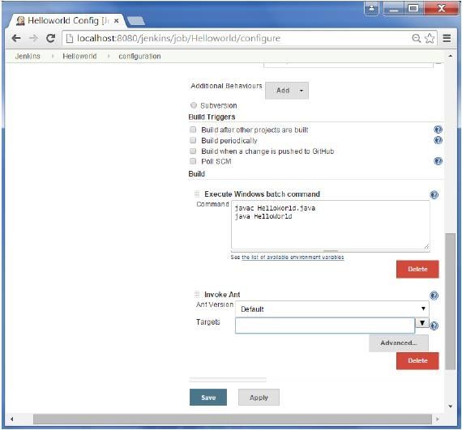

*38*

**Step4**−Inthebuildfilesection,enterthelocationofthebuild.xmlfile.

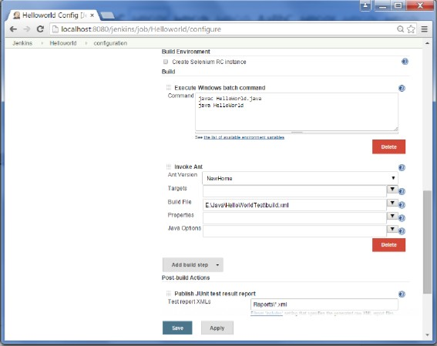

*39*

**Step 5** − Next click the option to Add post-build option and choose the option of“PublishJunittest result report”

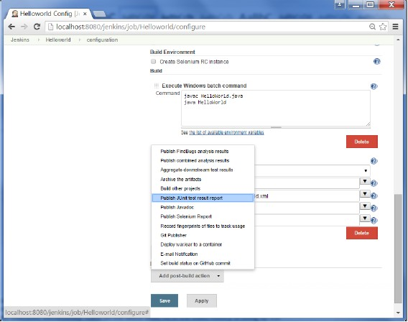

*40*

**Step 6** − In the Test reports XML’s, enter the location as shown below. Ensure thatReports is a folder which is created in the HelloWorld project workspace. The “*.xml”basicallytellsJenkinstopickuptheresultxmlfileswhichareproducedbytherunningof the Junit test cases. These xml files which then be converted into reports which canbeviewedlater.

Oncedone,clicktheSaveoptionattheend.

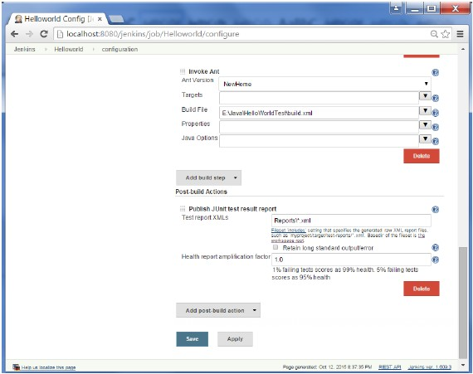

*41*

**Step7**−Oncesaved, youcanclickontheBuild Nowoption.

Oncethebuildiscompleted,astatusofthebuildwillshowifthebuildwassuccessfulornot. Inthe Buildoutputinformation,youwillnow notice anadditional sectioncalledTest Result. In our case, we entered a negative Test case so that the result would fail justasan example.

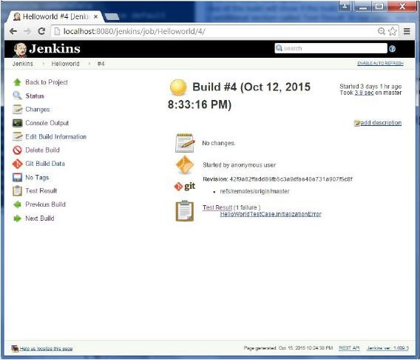

*42*

One can go to the Console output to see further information. But what’s moreinterestingisthatifyouclickonTestResult, youwillnowseeadrilldownoftheTestresults.

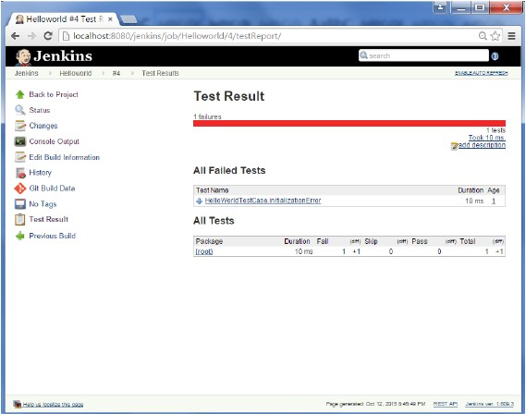

*43*

# Jenkins-AutomatedTesting

OneofthebasicprinciplesofContinuousIntegrationisthatabuild shouldbeverifiable.You have to be able to objectively determine whether a particular build is ready toproceed to the next stage of the build process, and the most convenient way to do thisis to use automated tests. Without proper automated testing, you find yourself havingto retain many build artifacts and test them by hand, which is hardly in the spirit ofContinuous Integration. The following example shows how to use Selenium to runautomatedweb tests.

**Step1**−GotoManagePlugins.

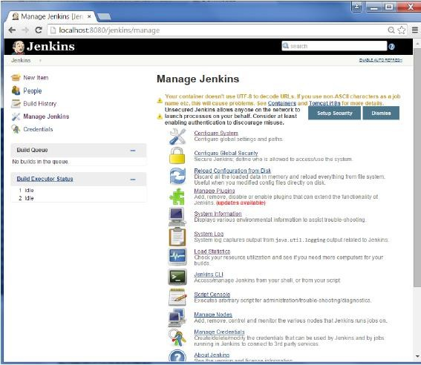

*44*

**Step2**−FindtheHudsonSeleniumPluginandchoosetoinstall.RestarttheJenkinsinstance.

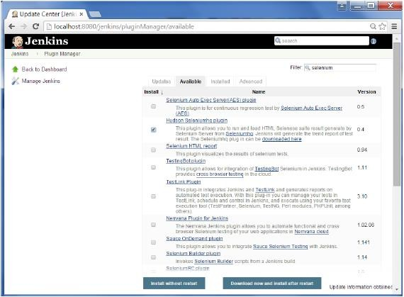

*45*

**Step3**−GotoConfiguresystem.

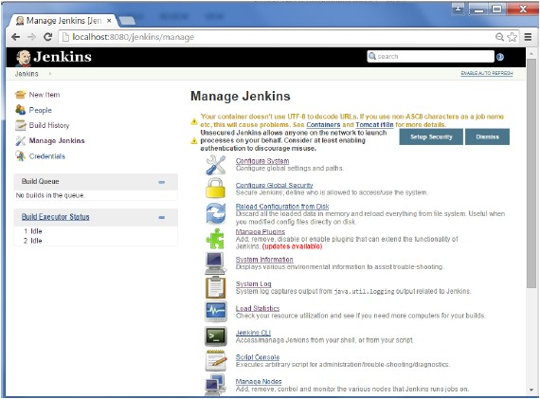

*46*

**Step4**−Configuretheseleniumserver jarandclickontheSavebutton.

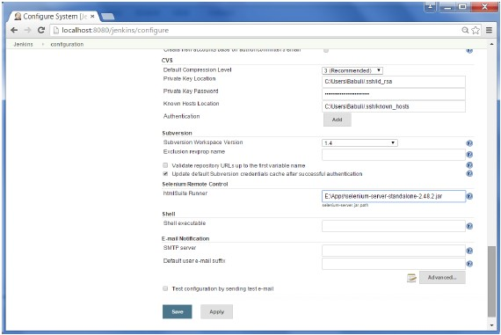

*47*

**Note**−TheseleniumjarfilecanbedownloadedfromthelocationSeleniumHQClickonthedownload fortheSeleniumstandaloneserver.

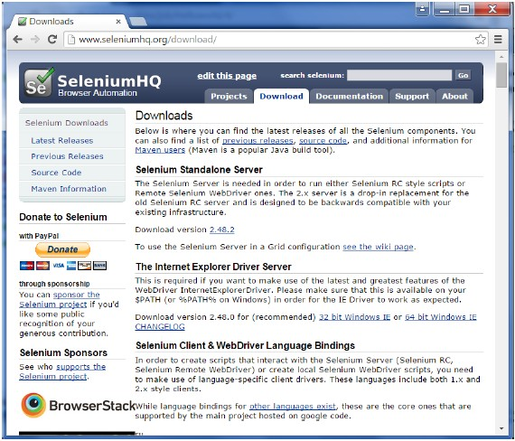

*48*

**Step5**−Gobackto yourdashboardandclickontheConfigureoptionfortheHelloWorldproject.

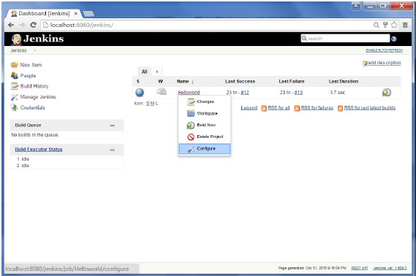

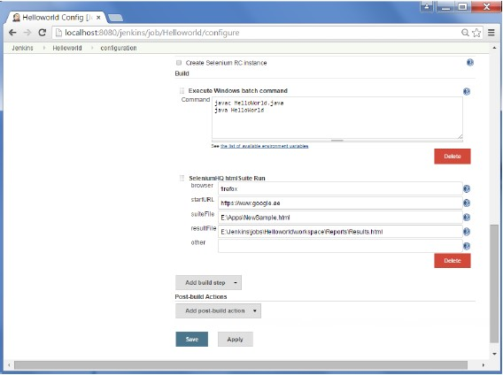

*49*

**Step6**−ClickonAddbuildstepandchoosetheoptinof“SeleniumHQhtmlSuiteRun”

**Step 7** − Add the necessary details for the selenium test. Here the suiteFile is theTestSuitegeneratedbyusingtheSeleniumIDE.ClickonSaveandexecuteabuild.Nowthepost buildwill launchtheseleniumdriver, and executethehtmltest.

*50*

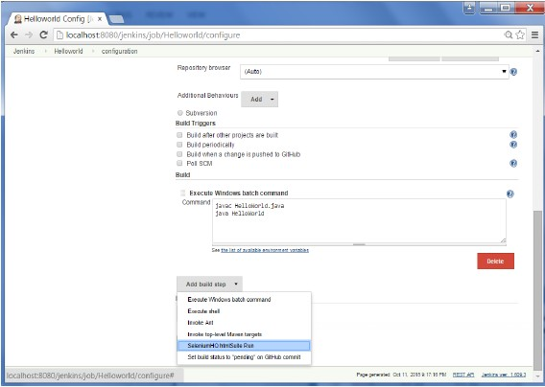

# Jenkins-Notification

Jenkinscomeswithan outofboxfacilityto addanemailnotificationforabuildproject.

**Step1**−ConfiguringanSMTPserver.GotoManageJenkins→ConfigureSystem.Gotothe E-mail notification section and enter the required SMTP server and user email-suffixdetails.

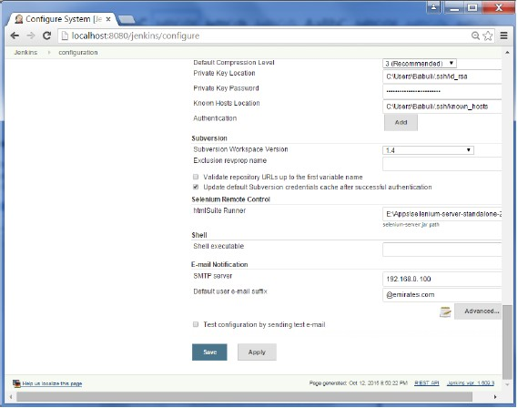

*51*

**Step 2** − Configure the recipients in the Jenkins project - When you configure anyJenkinsbuildproject,rightattheendistheabilitytoaddrecipientswhowouldgetemailnotificationsfor unstableorbrokenbuilds.ThenclickontheSavebutton.

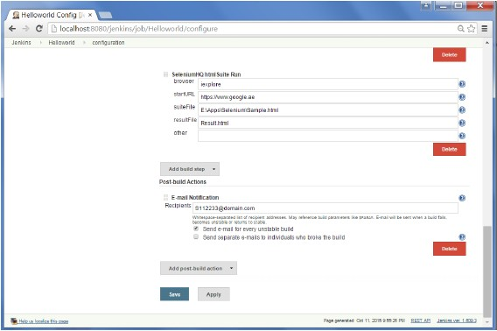

*52*

Apart from the default, there are also notification plugin’s available in the market. Anexample is the notification plugin from Tikal Knowledge which allows sending Job Statusnotifications in JSON and XML formats. This plugin enables end-points to be configuredasshownbelow.

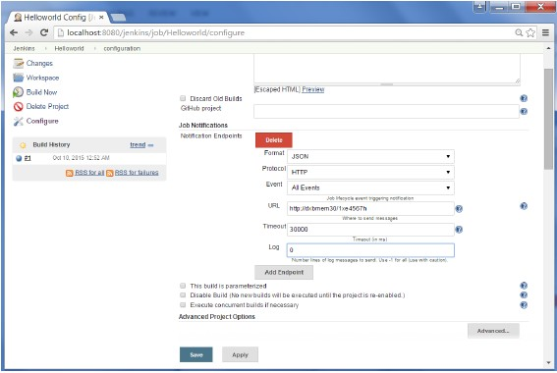

Herearethedetailsof eachoption −

* **"Format"** − This is the notification payload format which can either be JSON orXML.
* **"Protocol"**−protocoltouseforsendingnotificationmessages,HTTP,TCPorUDP.
* **"Event"**−Thejobeventsthattriggernotifications:JobStarted,JobCompleted,JobFinalized orAllEvents(thedefaultoption).
* **"URL"**−URLtosend notificationsto. Ittakestheformof"[http://host](http://host/)"forHTTPprotocol,and"host:port"forTCPand UDPprotocols.
* **"Timeout"**−Timeoutinmillisecondsforsendingnotificationrequest,30secondsbydefault.

# Jenkins-Reporting

Asdemonstratedintheearliersection,therearemanyreportingpluginsavailablewiththesimplest onebeingthereportsavailablefor jUnittests.

In the Post-build action for any job, you can define the reports to be created. After thebuildsarecomplete, theTest Resultsoptionwillbe availableforfurtherdrill-down.

*53*

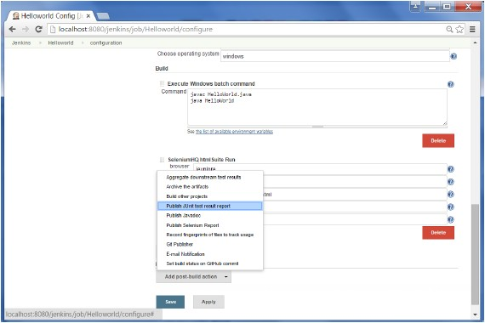

*54*

# Jenkins-CodeAnalysis

Jenkins has a host of Code Analysis plugin. The various plugins can be found athttps://wiki.jenkins-ci.org/display/JENKINS/Static+Code+Analysis+Plugins

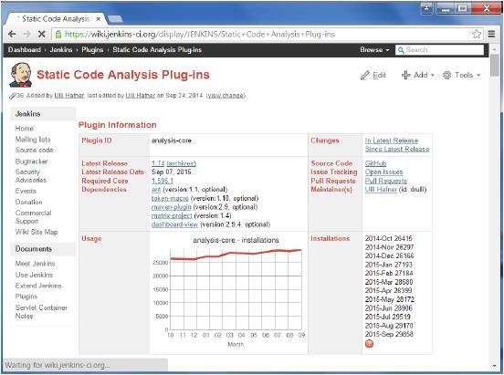

*55*

This plugin provides utilities for the static code analysis plugins. Jenkins can parse theresults file from various Code Analysis tools such as CheckStyle, FindBugs, PMD etc. Foreachcorrespondingcodeanalysistool,aplugininJenkinsneedstobeinstalled.

Additionallytheadd-onpluginStaticAnalysisCollectorisavailablethatcombinestheindividualresultsofthesepluginsintoasingletrend graphand view.

Thepluginscanprovideinformationsuchas

* Thetotalnumberof warningsina job
* Ashowingofthenewandfixedwarnings of a build
* TrendReportsshowingthenumberofwarningsperbuild
* Overviewofthefoundwarningspermodule,package,category,ortype
* Detailedreportsofthefoundwarnings optionally filteredbyseverity(or newandfixed)

# Jenkins-DistributedBuilds

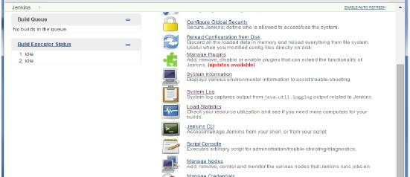

*56*

Sometimesmanybuildmachinesarerequiredifthereareinstanceswhereintherearealarger and heavier projects which get built on a regular basis. And running all of thesebuilds on a central machine may not be the best option. In such a scenario, one canconfigure other Jenkins machines to be slave machines to take the load off the masterJenkinsserver.

Sometimesyoumightalsoneedseveraldifferentenvironmentstotestyourbuilds.Inthis case using a slave to represent each of your required environments is almost amust.

A slave is a computer that is set up to offload build projects from the master and oncesetup this distribution of tasks is fairly automatic. The exact delegation behaviordependsontheconfigurationofeachproject;someprojectsmaychooseto"stick"toaparticularmachineforabuild,whileothersmaychoosetoroamfreelybetweenslaves.

Since each slave runs a separate program called a "slave agent" there is no need toinstallthefullJenkins(packageorcompiledbinaries)onaslave.Therearevariouswaysto start slave agents, but in the end the slave agent and Jenkins master needs toestablish a bi-directional communication link (for example a TCP/IP socket.) in order tooperate.

Tosetupslaves/nodesinJenkinsfollowthestepsgivenbelow.

**Step1**−Goto theManageJenkinssectionand scrolldownto thesectionofManageNodes.

**Step2**−ClickonNewNode

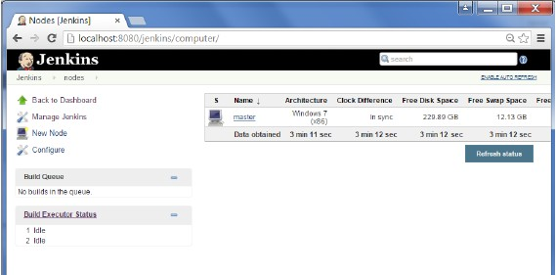

**Step3**−Giveanameforthenode,choosetheDumbslaveoptionandclickonOk.

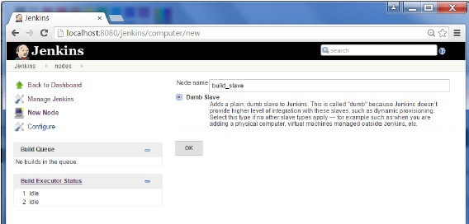

**Step 4** − Enter the details of the node slave machine. In the below example, we areconsidering the slave machine to be a windows machine, hence the option of “LetJenkins control this Windows slave as a Windows service” was chosen as the launchmethod. We also need to add the necessary details of the slave node such as the nodenameandthelogincredentialsforthenodemachine.ClicktheSavebutton.TheLabelsfor which the name is entered as “New_Slave” is what can be used to configure jobs tousethisslave machine.

*57*

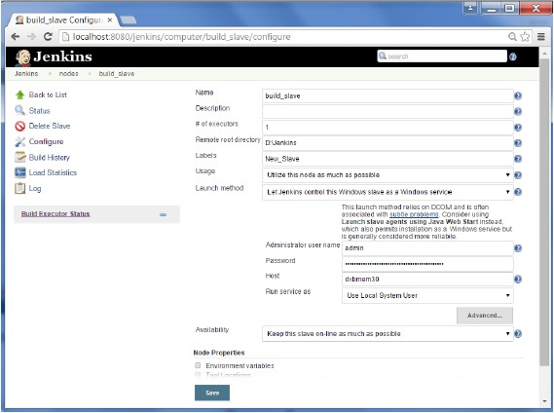

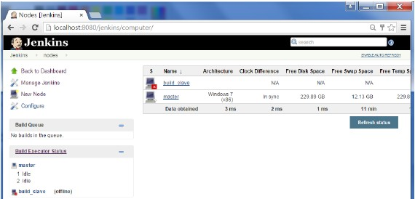

*58*

Oncetheabovesteps arecompleted,thenewnodemachinewillinitiallybeinanofflinestate, but will come online if all the settings in the previous screen were enteredcorrectly.Onecanatanytimemake thenodeslave machineasofflineifrequired.

# Jenkins-AutomatedDeployment

There are many plugins available which can be used to transfer the build files after asuccessfulbuildtotherespectiveapplication/webserver.Onexampleisthe“DeploytocontainerPlugin”. Tousethisfollowthe stepsgiven below.

**Step1**−GotoManageJenkins→ManagePlugins.GototheAvailablesectionand findtheplugin“DeploytocontainerPlugin”andinstalltheplugin.RestarttheJenkinsserver.

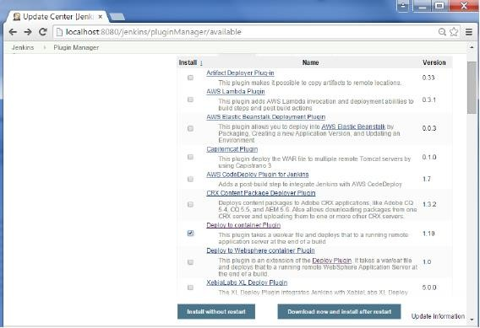

Thisplugintakesa war/earfileanddeploysthat toarunningremoteapplicationserverattheend ofabuild.

Tomcat 4.x/5.x/6.x/7.xJBoss3.x/4.x

Glassfish2.x/3.x

**Step2**−GotoyourBuildprojectandclicktheConfigureoption.Choosetheoption“Deploywar/earto acontainer”

*59*

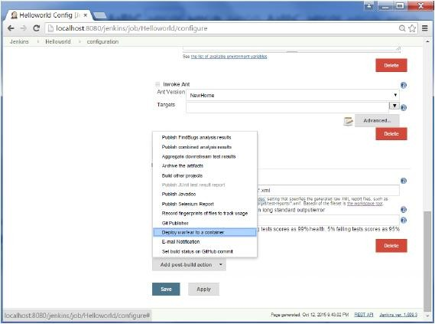

*60*

**Step 3** − In the Deploy war/ear to a container section, enter the required details of theserveronwhichthefilesneedtobedeployed andclickontheSavebutton.Thesestepswill now ensure that the necessary files get deployed to the necessary container after asuccessfulbuild.

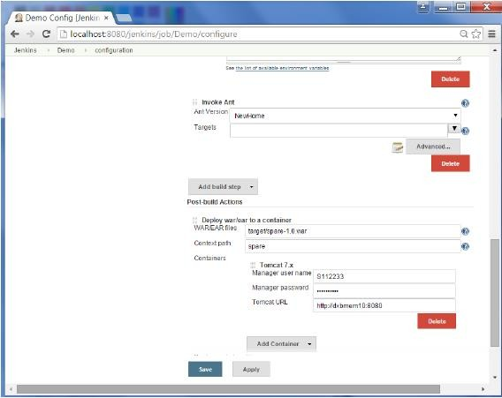

*61*

# Jenkins-Metrics&Trends

There are various plugins which are available in Jenkins to showcase metrics for buildswhich are carried out over a period of time. These metrics are useful to understand yourbuildsandhowfrequentlytheyfail/passovertime.Asanexample,let’slookatthe‘BuildHistoryMetricsplugin’.

Thisplugincalculatesthefollowingmetricsforallofthebuildsonceinstalled

* MeanTimeToFailure(MTTF)
* MeanTimeToRecovery(MTTR)
* StandardDeviationofBuildTimes

**Step1**−GototheJenkinsdashboard andclickon ManageJenkins

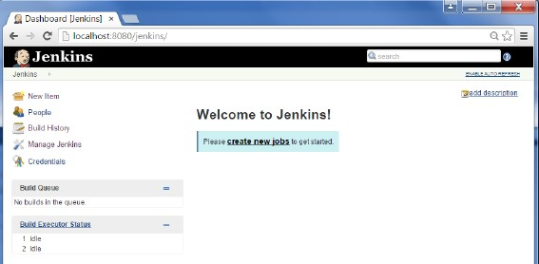

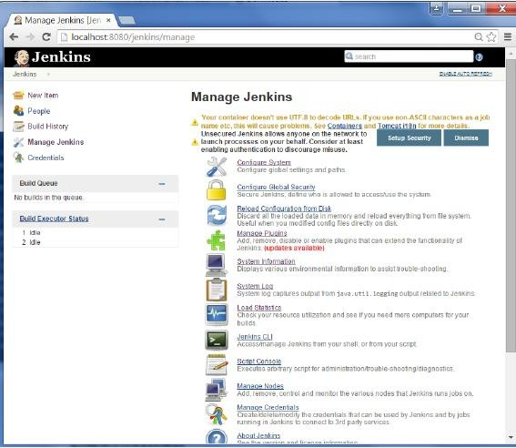

**Step2**−Goto theManagePluginsoption.

*62*

**Step3**−Goto theAvailabletabandsearchfor theplugin‘BuildHistoryMetricsplugin’andchooseto ‘install without restart’.



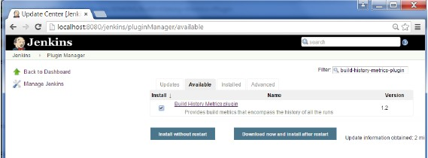

**Step 4** − The following screen shows up to confirm successful installation of the plugin.RestarttheJenkinsinstance.

WhenyougotoyourJobpage,youwillseeatablewiththecalculatedmetrics.Metric’sareshownforthelast7days, last 30daysand alltime.

*63*

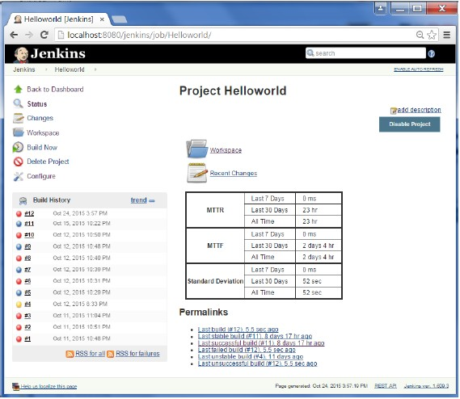

*64*

To see overall trends in Jenkins, there are plugins available to gather information fromwithin the builds and Jenkins and display them in a graphical format. One example ofsuchapluginisthe‘Hudsonglobal-build-statsplugin’.Solet’sgothrough thestepsforthis.

**Step1**−GototheJenkinsdashboard andclickonManageJenkins

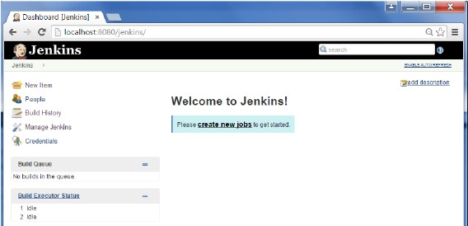

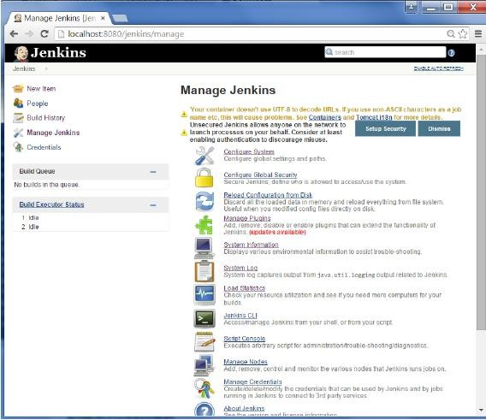

**Step2**−Goto theManagePluginsoption

*65*

**Step 3** − Go to the Available tab and search for the plugin ‘Hudson global-build-statsplugin’and chooseto ‘installwithoutrestart’.

*66*

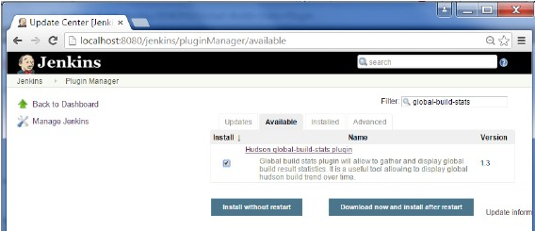

**Step 4** − The following screen shows up to confirm successful installation of the plugin.RestarttheJenkinsinstance.

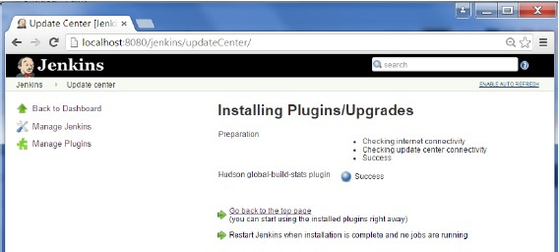

ToseetheGlobalstatistics,pleasefollowtheStep5through8.

**Step 5** − Go to the Jenkins dashboard and click on Manage Jenkins. In the ManageJenkins screen, scroll down and now you will now see an option called ‘Global BuildStats’.Clickon thislink.

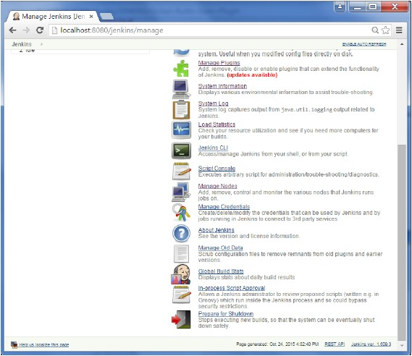

*67*

**Step6**−Clickonthe button‘Initializestats’. Whatthisdoesisthatitgather’salltheexisting records for builds which have already been carried out and charts can becreatedbasedontheseresults.

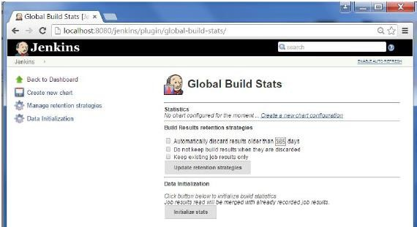

*68*

**Step7**−Oncethedatahasbeeninitialized,it’stimeto createanewchart. Clickonthe‘Createnewchart’link.

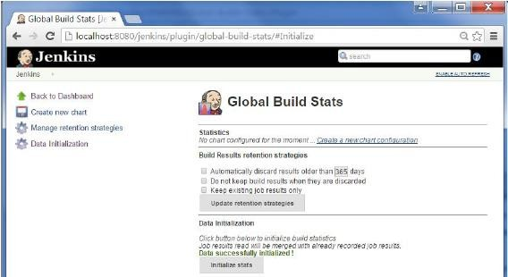

**Step8**−Apop-up willcometoenterrelevant informationforthenewchartdetails.Enterthefollowingmandatoryinformation

**Title – Any title information, for this example is given as ‘Demo’ChartWidth –800

**Chart Height – 600Charttimescale–Daily

*Charttimelength–30days

*69*

The rest of the information can remain as it is. Once the information is entered, click onCreateNewchart.

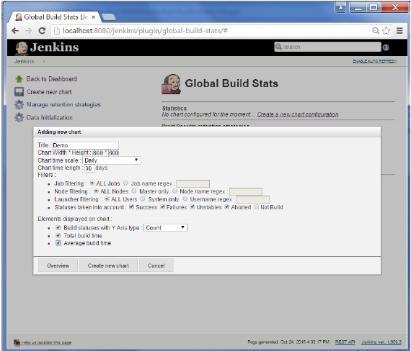

Youwillnowseethe chartwhichdisplaysthetrendsofthebuilds overtime.

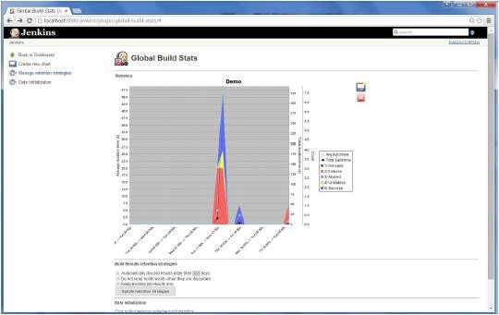

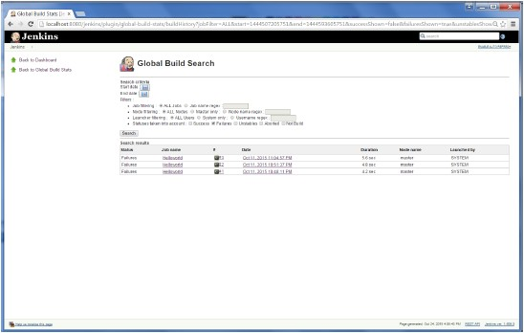

*70*

Ifyouclickon anysectionwithinthechart, itwillgiveyouadrilldownofthedetailsofthejoband their builds.

# Jenkins-ServerMaintenance

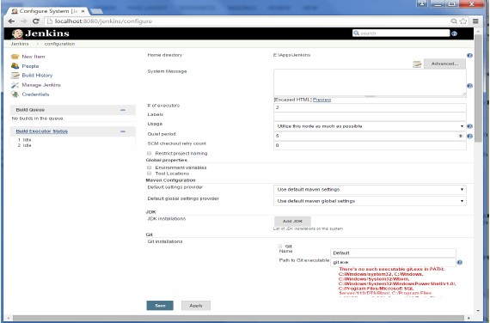

*71*

Thefollowingaresomeofthebasicactivitiesyouwillcarryout,someofwhicharebestpracticesforJenkins server maintenance

## URLOptions

ThefollowingcommandswhenappendedtotheJenkinsinstanceURLwillcarryouttherelevantactionsontheJenkins instance.

**http://localhost:8080/jenkins/exit** − shutdown jenkins**http://localhost:8080/jenkins/restart** − restart jenkins**http://localhost:8080/jenkins/reload**−toreloadtheconfiguration

## BackupJenkinsHome

The Jenkins Home directory is nothing but the location on your drive where Jenkinsstoresallinformationforthejobs,buildsetc. Thelocationofyourhomedirectorycanbeseenwhenyouclickon ManageJenkins→Configuresystem.

Set up Jenkins on the partition that has the most free disk-space – Since Jenkins wouldbe taking source code for the various jobs defined and doing continuous builds, alwaysensurethatJenkinsissetuponadrivethathasenoughharddiskspace.Ifyouharddiskrunsout ofspace, thenallbuildsontheJenkinsinstancewillstart failing.

*72*

Anotherbestpracticeistowritecronjobsormaintenancetasksthatcancarryoutclean-upoperationstoavoidthediskwhere Jenkinsissetupfrombecomingfull.

# Jenkins-ContinuousDeployment

Jenkins provides good support for providing continuous deployment and delivery. If youlook at the flow of any software development through deployment, it will be as shownbelow.

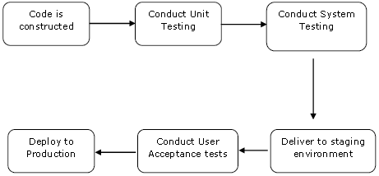

The main part of Continuous deployment is to ensure that the entire process which isshown above is automated. Jenkins achieves all of this via various plugins, one of thembeingthe“DeploytocontainerPlugin” whichwasseeninthe earlier lessons.

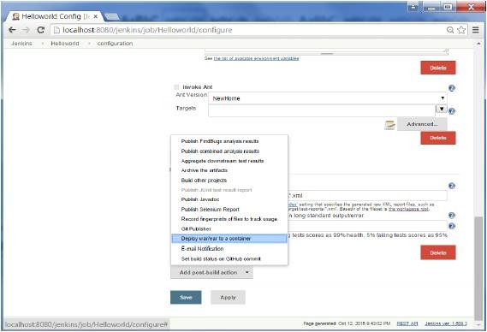

*73*

TherearepluginsavailablewhichcanactuallygiveyouagraphicalrepresentationoftheContinuous deployment process. But first lets create another project in Jenkins, so thatwecanseebest howthisworks.

Let’screate asimpleprojectwhichemulatestheQAstage,anddoesatest oftheHelloworldapplication.

**Step 1** − Go to the Jenkins dashboard and click on New Item. Choose a ‘Freestyleproject’andentertheprojectnameas‘QA’.ClickontheOkbuttontocreatetheproject.

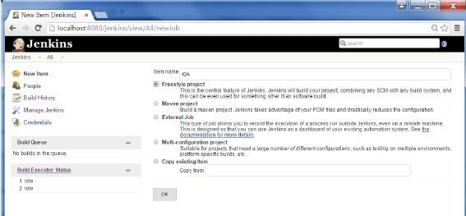

*74*

**Step2**−Inthisexample,wearekeepingit simpleandjustusingthisprojecttoexecuteatest programforthe Helloworld application.

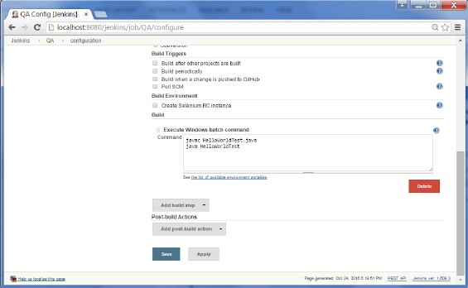

Soour projectQA isnowsetup.You candoabuildto seeifitbuildsproperly.

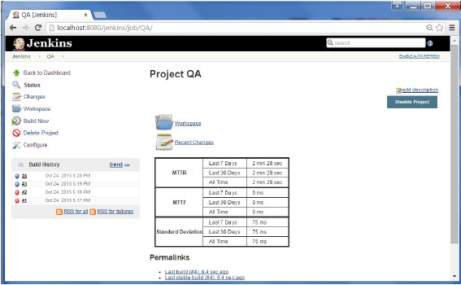

**Step3**−NowgotoyouHelloworldprojectandclickontheConfigureoption

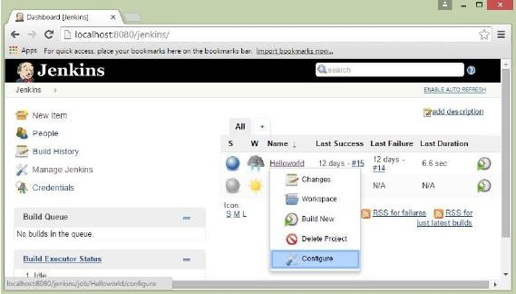

**Step 4** − In the project configuration, choose the ‘Add post-build action’ and choose‘Buildother projects’

*75*

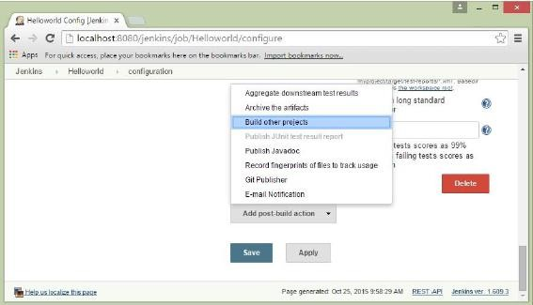

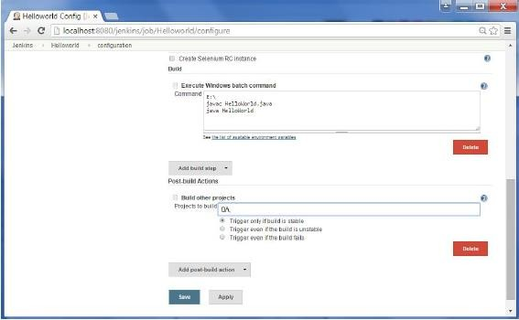

**Step 6** − Build the Helloworld project. Now if you see the Console output, you will alsoseethatafter theHelloworldprojectissuccessfullybuilt,thebuildoftheQAprojectwillalsohappen.

*76*

**Step5**−Inthe‘Projectto build’section, enterQA astheprojectnameto build.You canleavetheoption asdefaultof‘Triggeronlyifbuild isstable’.ClickontheSavebutton.

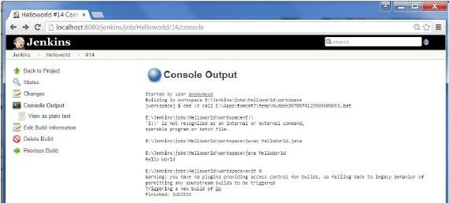

*77*

**Step 7** − Let now install the Delivery pipeline plugin. Go to Manage Jenkins → ManagePlugin’s. In the available tab, search for ‘Delivery Pipeline Plugin’. Click On Install withoutRestart.Oncedone, restart theJenkinsinstance.

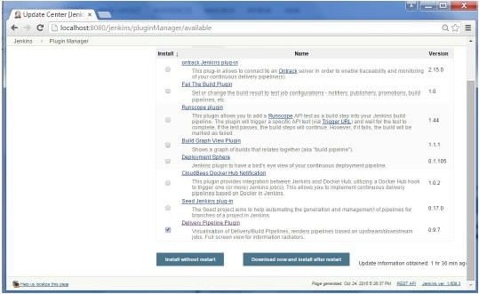

**Step8**−ToseetheDeliverypipelineinaction,intheJenkinsDashboard,clickonthe+symbolinthe Tabnextto the‘All’Tab.

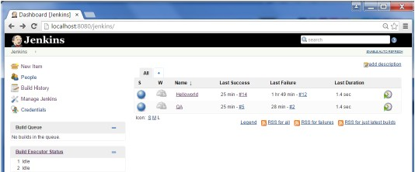

*78*

**Step 9** − Enter any name for the View name and choose the option ‘Delivery PipelineView’.

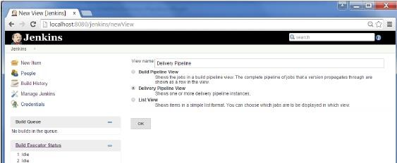

**Step10**−Inthenextscreen,youcanleavethedefaultoptions.Onecanchangethefollowingsettings −

**Ensure the option ‘Show static analysis results’ is checked.Ensuretheoption‘Showtotalbuildtime’ischecked.

**For the Initial job – Enter the Helloworld project as the first job which should build.Enteranynamefor thePipeline

*ClicktheOKbutton.

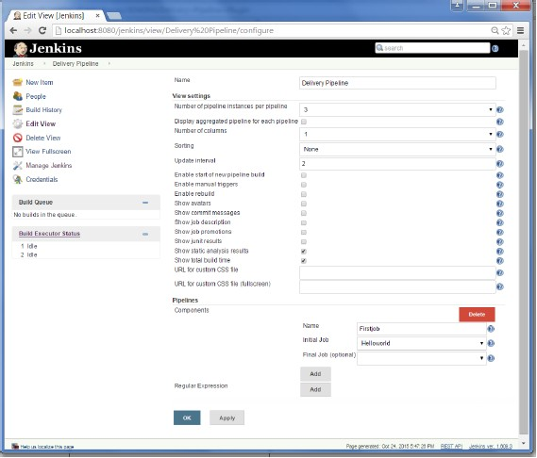

*79*

Youwillnowseeagreatviewoftheentiredeliverypipelineand you willbe abletoseethestatusofeachprojectintheentire pipeline.

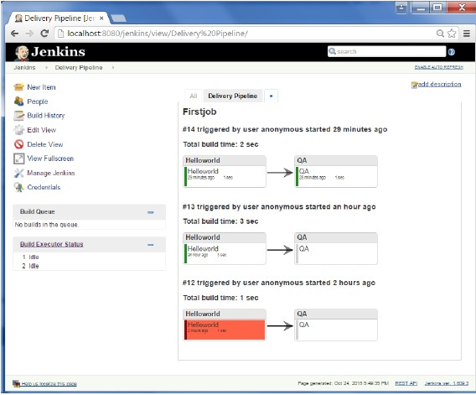

*80*

Anotherfamouspluginisthe **buildpipelineplugin**.Let’stakealookatthis.

**Step 1** − Go to Manage Jenkins → Manage Plugin’s. In the available tab, search for‘Build Pipeline Plugin’. Click On Install without Restart. Once done, restart the Jenkinsinstance.

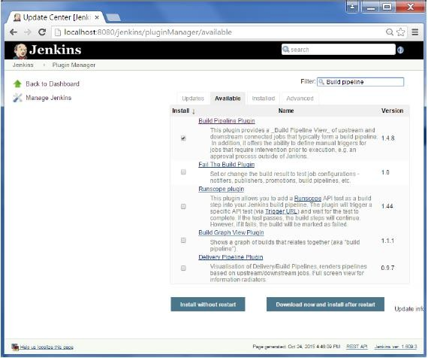

*81*

**Step2**−Toseethe Buildpipelineinaction,intheJenkinsDashboard,clickon the+symbolinthe Tabnextto the‘All’Tab.

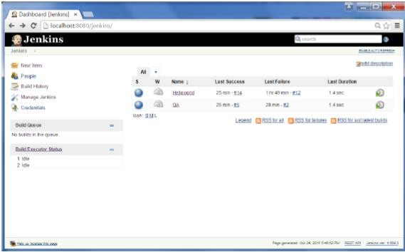

*82*

**Step3**−EnteranynamefortheViewnameandchoosetheoption‘BuildPipelineView’.

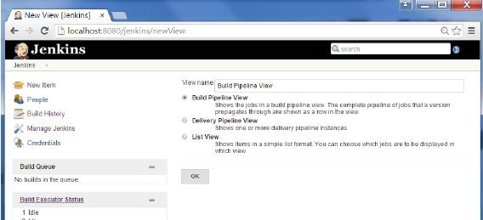

**Step4**−Acceptthedefaultsettings,justintheSelectedInitialjob, ensuretoenterthenameoftheHelloworldproject. Clickonthe Okbutton.

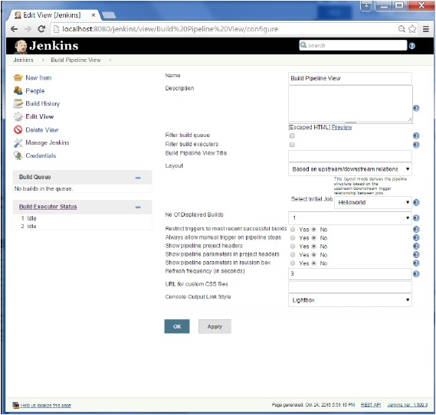

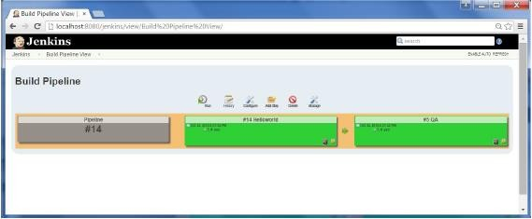

*83*

Youwillnowseeagreatviewoftheentiredeliverypipelineand you willbe abletoseethestatusofeachprojectintheentire pipeline.

# Jenkins-ManagingPlugins

*84*

TogetthelistofallpluginsavailablewithinJenkins,onecanvisitthelink−https://wiki.jenkins-ci.org/display/JENKINS/Plugins

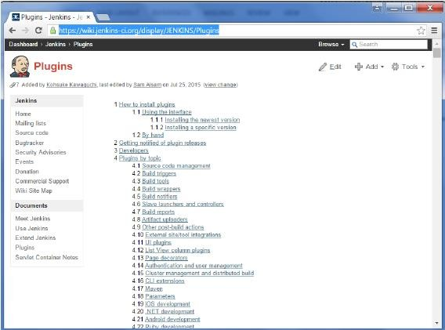

We’vealreadyseenmanyinstancesforinstallingplugins,let’slookatsomeothermaintenancetaskswithregardsto plugins

## UninstallingPlugins

To uninstall a plugin, Go to Manage Jenkins → Manage plugins. Click on the Installedtab.SomeofthepluginswillhavetheUninstalloption.Youcanclickthesebuttonstouninstalltheplugins.EnsuretorestartyourJenkinsinstanceaftertheuninstallation.

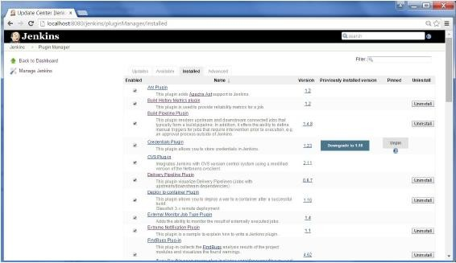

*85*

## InstallinganotherVersionofaPlugin

Sometimes it may be required to install an older version of a plugin, in such a case, youcandownloadthepluginfromtherelevantpluginpageontheJenkinsweb site.Youcanthenusethe**Upload**optionto upload thepluginmanually.

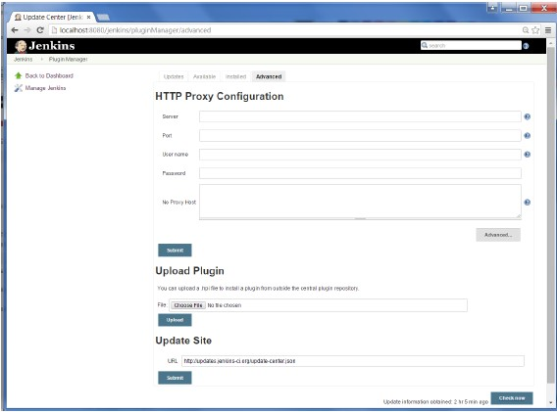

*86*

# Jenkins-Security

In Jenkins you have the ability to setup users and their relevant permissions on theJenkinsinstance.Bydefaultyouwillnotwanteveryonetobeabletodefinejobsorotheradministrative tasks in Jenkins. So Jenkins has the ability to have a security configurationinplace.

ToconfigureSecurityinJenkins,followthestepsgivenbelow.

**Step1**−ClickonManageJenkinsandchoosethe‘ConfigureGlobalSecurity’option.

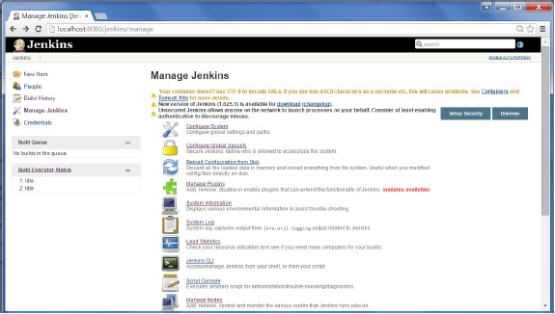

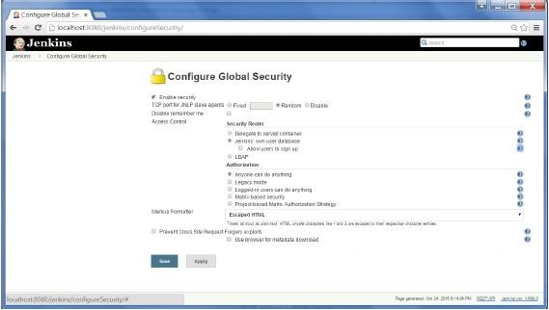

*87*

**Step 2** − Click on Enable Security option. As an example, let’s assume that we wantJenkinstomaintainit’sowndatabaseofusers,sointheSecurityRealm,choosetheoptionof‘Jenkins’ownuser database’.

By default you would want a central administrator to define users in the system, henceensurethe‘Allowuserstosignup’option isunselected.Youcanleavetherestasitisfornowand clicktheSave button.

**Step3**−Youwillbepromptedtoaddyourfirstuser.Asanexample,wearesettingupanadmin usersforthe system.

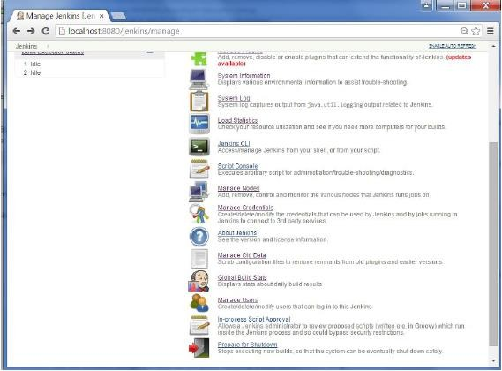

*88*

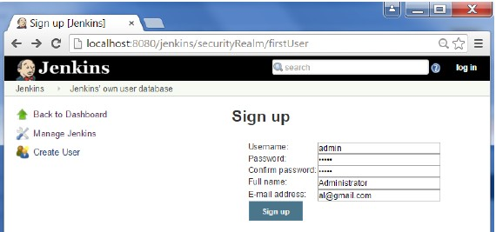

**Step4**−It’snowtimetosetupyour usersinthesystem. Nowwhen yougo toManageJenkins,andscrolldown, youwillseea‘ManageUsers’ option.Clickthisoption.

**Step5**−Justlikeyoudefinedyouradminuser,startcreatingotherusersforthesystem.Asan example, weare justcreatinganother user called ‘user’.

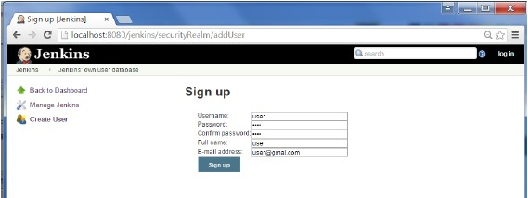

**Step6**−Nowit’stimetosetupyourauthorizations,basicallywhohasaccesstowhat.Goto ManageJenkins→ConfigureGlobalSecurity.

NowintheAuthorizationsection,clickon‘Matrixbasedsecurity’

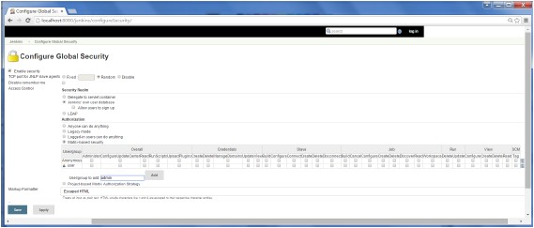

**Step 7** − If you don’t see the user in the user group list, enter the user name and add ittothelist.Thengivetheappropriatepermissionsto theuser.

ClickontheSavebuttononceyouhavedefinedtherelevantauthorizations.YourJenkinssecurityisnowsetup.

**Note** − For Windows AD authentication, one has to add the Active Directory plugin toJenkins.

*89*

# Jenkins-BackupPlugin

Jenkins has a backup plugin which can used to backup critical configuration settingsrelatedto Jenkins.Followthestepsgiven belowtohaveabackup inplace.

**Step1**−ClickonManageJenkinsandchoosethe‘ManagePlugins’option.

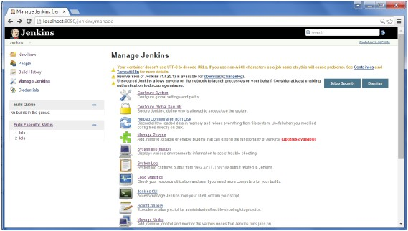

**Step2**−Intheavailabletab,searchfor‘BackupPlugin’.ClickOnInstallwithoutRestart.Oncedone, restart theJenkinsinstance

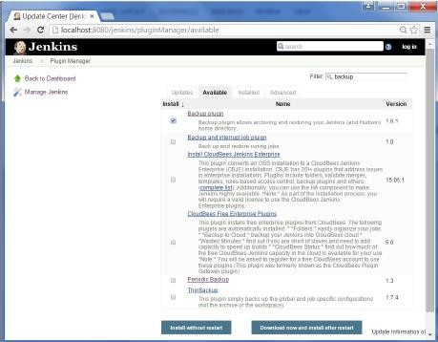

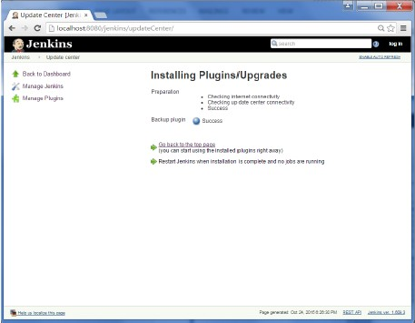

**Step3**−NowwhenyougotoManageJenkins,andscrolldownyouwillsee‘BackupManager’asan option.Clickonthisoption.

*91*

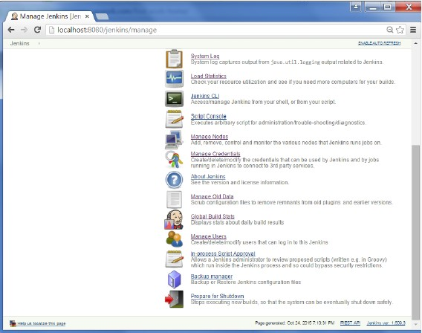

**Step4**−ClickonSetup.

**Step5**−Here, themainfieldtodefineisthedirectoryforyourbackup.Ensureit’sonanotherdrivewhichisdifferentfromthedrivewhere yourJenkinsinstanceissetup.

ClickontheSavebutton.

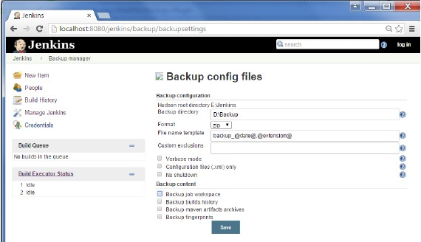

**Step6**−Clickonthe‘BackupHudsonconfiguration’fromtheBackup managerscreentoinitiatethebackup.

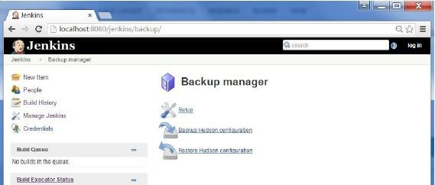

Thenext screenwill showthestatusofthebackup

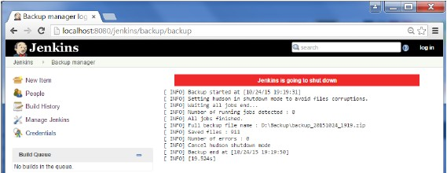

To recover from a backup, go to the Backup Manager screen, click on Restore Hudsonconfiguration.

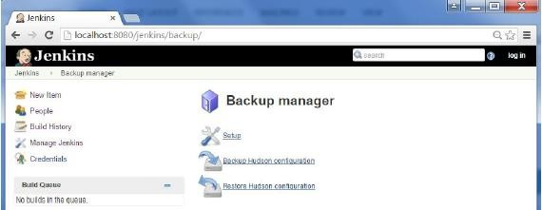

Thelistofbackup’swillbeshown,clickontheappropriateonetoclickonLaunchRestoreto begin therestorationofthebackup.

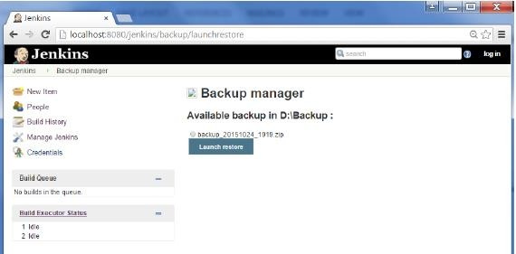

**Resources**

htt[ps://w](http://www.jenkins.io/)ww.je[nkins.io/](http://www.jenkins.io/)htt[ps://w](http://www.jenkins.io/doc/)ww.je[nkins.io/doc/](http://www.jenkins.io/doc/)

htt[ps://w](http://www.jenkins.io/doc/book/system-administration/)ww.je[nkins.io/doc/book/system-administration/](http://www.jenkins.io/doc/book/system-administration/)htt[ps://w](http://www.tutorialandexample.com/jenkins-tutorial/)ww[.tutorialandexamp](http://www.tutorialandexample.com/jenkins-tutorial/)le[.com/jenkins](http://www.tutorialandexample.com/jenkins-tutorial/)-[tutorial/](http://www.tutorialandexample.com/jenkins-tutorial/)